## 

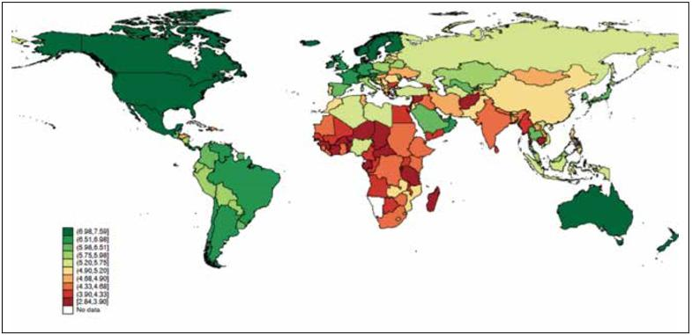

Plotly-World Happiness Report

10.01.2017

**─**Team Members: Manjusha Z, Vaibhav Kulkarni, Anna Anitha, Anupam Singh, Akhil Siddharth  
T54  
HPDF

# Overview

To deploy a custom service, both web and mobile based, in Hasura which allows users to pick a metric/metrics from a list based on World Happiness Report and plots the data for the chosen metric(s).

# Goals

1. Download the .CSV file of the World Happiness Report from <https://www.kaggle.com/unsdsn/world-happiness/downloads/2017.csv>
2. Store the data from the dataset in the Postgres database of a Hasura Cluster.
3. Design a UI which allow users to pick a metric to be plotted from a list of fields of the dataset.
4. Fetch data for the chosen metric(s) from the dataset using data APIs.
5. Plot the data for the chosen metric(s) based on the selected chart type.

# Technology stack

* Front-end: ReactJS, React Native
* Back-end: Python-Flask, NodeJS-Express
* DataBase: PostgreSQL
* Server: Nginx

# List of resources/documentation

* Plotly.js is a high-level, declarative charting library.
* Hasura data APIs are the fastest way to access data from your app.
* Postgres instance in the hasura cluster

# Milestones

## Backend:

* Store the .csv file regarding world happiness report in postgres database of hasura cluster.
* Provide an endpoint to front end developers to access the database and for fetching the data.
* User authentication is to be implemented.

## 

## Frontend:

* Design a login screen where user credentials are validated and new users are allowed to register.
* Design Ui for allowing users to pick a metric from the list based on the dataset stored in the database.
* Allow users to select a chart type from a given list.
* By using plotly.js library, plot the data for the chosen metric(s).

## Common:

* Create a common git repo vaibhavk98/plotlyjsT54.git on github.
* Create a hasura cluster and all the team members as collaborators.

# Basic Wireframe



# 

# How it works:

